**Sprint** 3 Agility - System **Design Document**

April 18, **2022**

**Table of Contents**

**1.** **EXECUTIVE SUMMARY 3**

1.1 Project Overview 3

1.2 Purpose and Scope of this Specification 3

**2.** **PRODUCT/SERVICE DESCRIPTION 3**

2.1 Product Context 3

2.2 User Characteristics 3

2.3 Assumptions 3

2.4 Constraints 3

2.5 Dependencies 4

**3.** **REQUIREMENTS 4**

3.1 Functional Requirements 5

3.2 Security 5

*3.2.1* *Protection 5*

*3.2.2* *Authorization and Authentication* 5

3.3 Portability 5

**4.** **REQUIREMENTS CONFIRMATION/STAKEHOLDER SIGN-OFF** 5

**5.** **SYSTEM DESIGN 6**

5.1 Algorithm 6

5.2 System Flow 7

5.3 Software 8

5.4 Hardware 9

5.5 Test Plan 9

5.6 Task List/Gantt Chart 10

5.7 Staffing Plan 10

# Executive Summary

## ***Project Overview***

This document includes some of the documents, files, and other information required for the agility-sprint portion (Sprint 3) of the CS104 Robotics Triathlon as outlined in the CS 104-01 Class syllabus for Spring 2022. The robot must complete an obstacle course on the floor of room HH-208. A video will be taken to show the robot completing its task.

## ***Purpose and Scope of this Specification***

**In scope**

* This part includes the testing for the agility (obstacle course) portion only, this is further explained in section 2.1

**Out of Scope**

* This part does not involve the testing for Accuracy or Endurance

# Product/Service Description

## ***Product Context***

This project is part 2 of the robotics triathlon containing three different sprints. The three sprints are Endurance, Accuracy, and Agility. This part contains the Agility section of the project. Each section will be presented via video format.

## ***User Characteristics***

Our group contains three students testing, recording, and fixing the robot when it needs to be. A final video is to be presented at the end of the project. Our group members have little experience having used this type of robot only in the two previous sprints however, group members have some experience working with the block code.

## ***Assumptions***

We are using a robot called the SPRK+ and we will be using Sphero Edu for the programming and block code. This app can be used on our phones or laptops, but we programmed the robot using our laptops. The course we are following is inside room HH-208. We will be using an iPhone 13 when filming the robot.

## ***Constraints***

Some constraints for this project included the room and course not always being available to use, this limited the time we had to work together to test and make changes to the robot. Other constraints included finding the right time for us all to meet up and work together on the project. Some members had busy schedules which caused major time constraints. Some other problems included other groups using the room at the same time as us, which made it harder when both robots were on the same course.

## ***Dependencies***

Some dependencies include the robot being charged in order for it to work. The robot to be up to date in order for it to follow the block code successfully. Other dependencies are making sure the robot can accurately repeat coded loops so it may repeat the figure eight course with precision and accuracy.

# Requirements

## ***Functional Requirements***

| **Req#** | **Requirement** | **Comments** | **Priority** | **Date Rvwd** | **SME Reviewed / Approved** |
| --- | --- | --- | --- | --- | --- |
| AGILITY_01 | Robot must not hit any of the glass pins |  | 1 | 4/13 | 4/13 |
| AGILITY_02 | robot must have enough speed to get over the jump | This was very difficult as the team had to calculate the exact speed required to get over the ramp. | 1 | 4/13 | 4/13 |
| AGILITY_04 | the robot must land still inside of the course | This portion was difficult as the velocity of the robot after the jump could make the robot go further than necessary | 1 | 4/13 | 4/13 |
| AGILITY_05 | the robot must rotate towards the pins |  | 1 | 4/13 | 4/13 |
| AGILITY_06 | the robot must hit all pins in the course |  | 1 | 4/13 | 4/13 |

## ***Security***

### **Protection**

The key for the protection of the software and hardware was with the group's overall accountability. The robot itself was always with one of the group members at all times and each time it was used was with all members present. In addition, each time the software was manipulated and changed, the progress was saved and logged.

### **Authorization and Authentication**

Pubcookie will be used for authorization of each user trying to use the software. Users simply trying to use the software for their own personal trials will be authenticated as “guest” and the group members associated with the overall project will be authenticated as “Accuracy.”

## ***Portability***

Due to the fact that the Sphero Edu program is portable on most systems, the code used in this project can be easily used on many different devices and networks. All any user must do is download the appropriate version of Sphero that corresponds to their operating system. The only portion of the project that is not portable is the course itself.

# Requirements Confirmation/Stakeholder sign-off

| **Meeting Date** | **Attendees (name and role)** | **Comments** |
| --- | --- | --- |
| 4/13/2022 | Chalen, Jack, Dennis | Met to test the robot |

# System Design

## ***Algorithm***

1. Start
2. Roll 0 degrees with speed of 30 for 3.35 seconds
3. delay for 1 second
4. stabilize
5. roll 94 degrees with speed of 30 for 3.6 seconds
6. delay for 1 second
7. stabilize
8. roll 0 degrees with speed of 30 for 4.25 seconds
9. delay for 1 second
10. stabilize
11. roll 96 degrees with speed of 255 for 1.6 seconds
12. stop
13. delay for 4 seconds
14. roll 225 degrees with speed of 137 for 3 seconds
15. exit program

## ***System Flow***

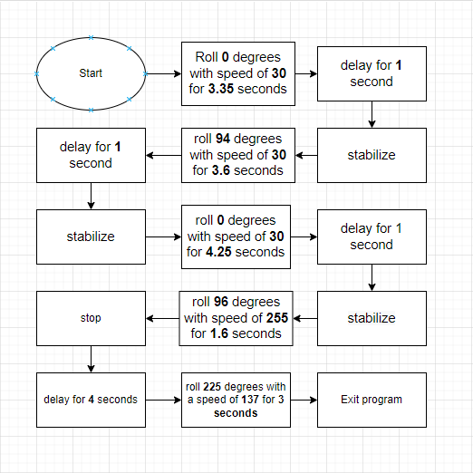

## ***Software***

* Sphero Edu program version 6.3.5
* macOS Big Sur Version 11.4 operating system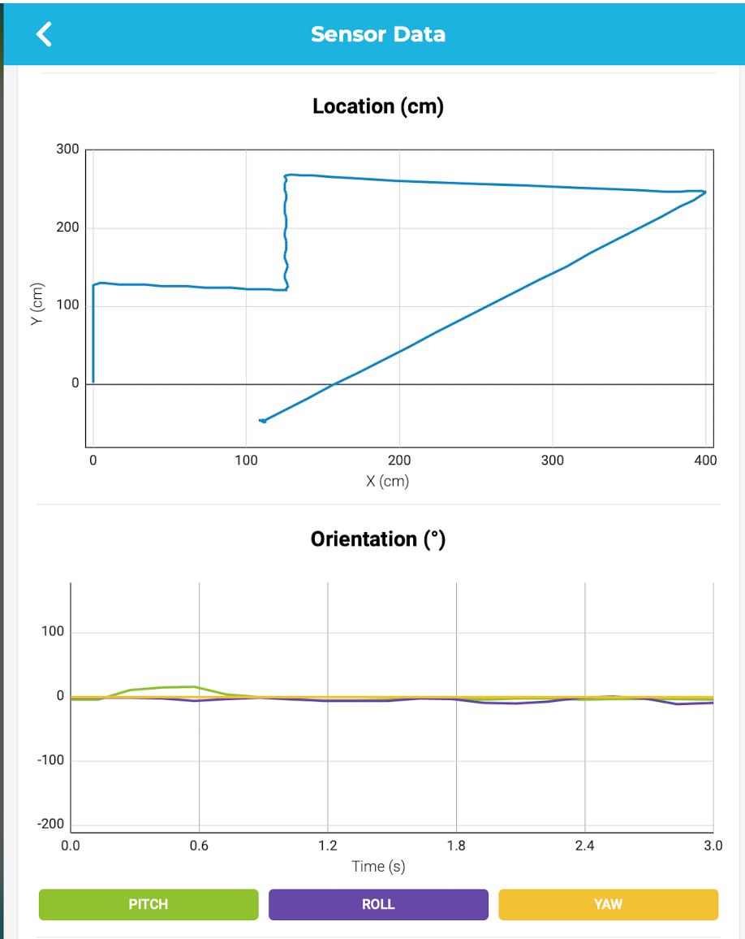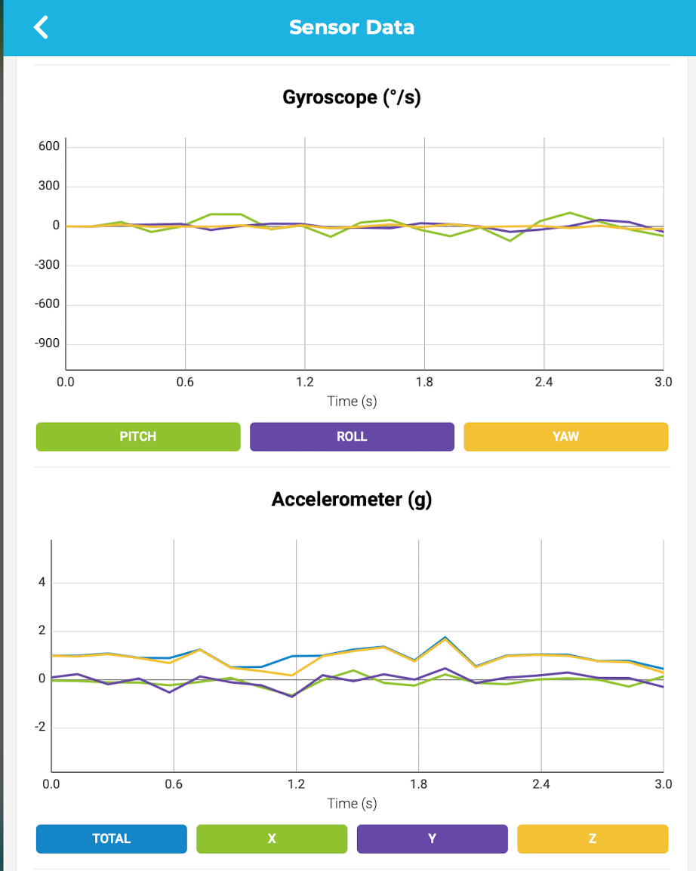

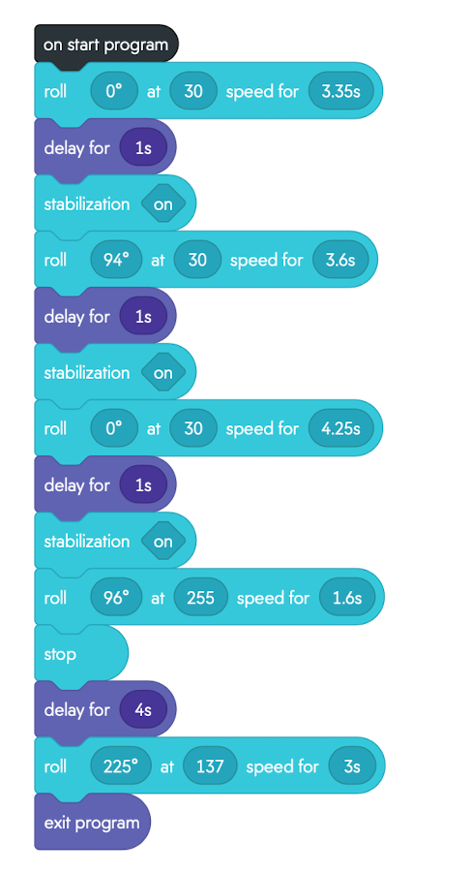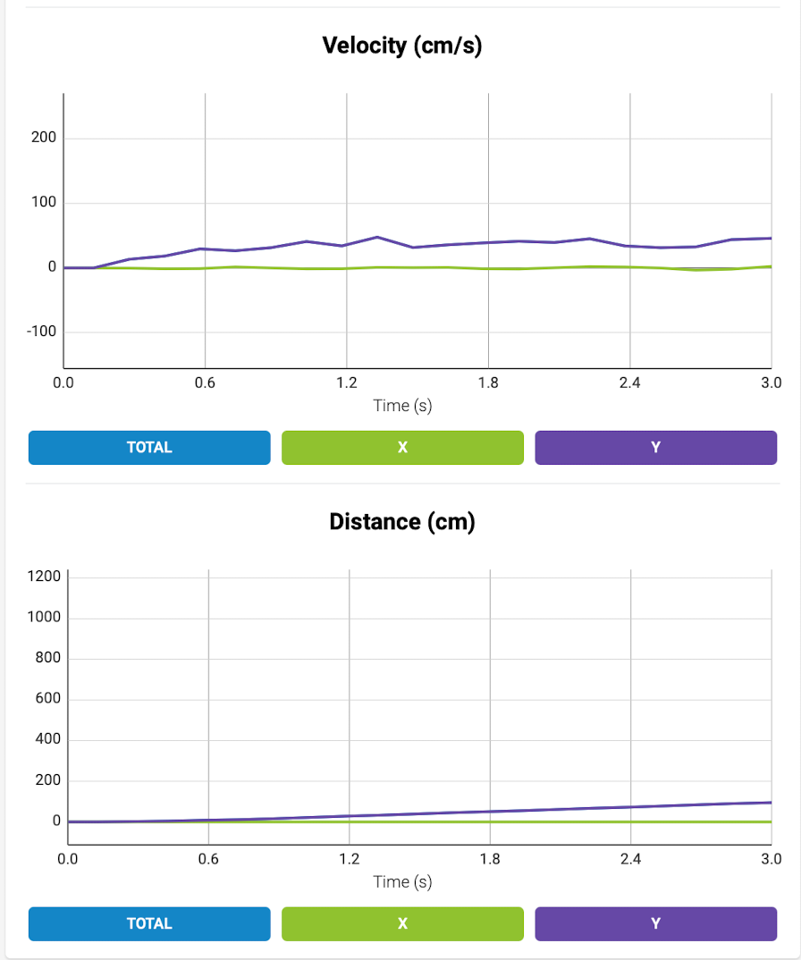

## ***Hardware***

* 2013 MacBook Pro (Late 2013)
* 2.4 GHz Dual-Core Intel Core i5 processor
* 8 GB 1600 MHz DDR3 memory
* Sphero Sprk+ robot

## ***Test Plan***

| **Reason for Test Case** | **Test Date** | **Expected Output** | **Observed Output** | **Staff Name** | **Pass/Fail** |
| --- | --- | --- | --- | --- | --- |
| Gauge approximate speed and distance needed to complete first vertical section of the course | 04/13/2022 | Robot will not be successful at traveling 1st measured distance | Robot traveled too short a distance. | DV | Fail |
| complete first vertical section of the course, pivot 90 degrees, and travel the second distance | 04/13/2022 | Robot will complete the first distance of the course successfully, then pivot approximately 90 degrees to travel the second distance | incorrect aim, (struck bottles) | DV | Fail |
| complete first vertical section of the course, pivot 90 degrees, and travel the second distance | 04/13/2022 | Robot will complete the first distance of the course successfully, then pivot approximately 90 degrees to travel the second distance | Robot traveled first length successfully, but pivoted incorrectly and struck the second bottle | DV | Fail |
| complete first vertical section of the course, pivot 90 degrees, and travel the second distance | 04/13/2022 | Robot will complete the first distance of the course successfully, then pivot 94 degrees to travel the second distance | Robot complete the first two sections of the course | DV | Pass |
| Successfully navigate around all three bottles, pivot 90 degrees, then travel at a speed of 150 for 3 seconds in order to clear the jump | 04/13/2022 | Robot will successfully navigate around all three bottles, pivot 90 degrees, then travel at maximum speed for 3 seconds and hopefully make contact with the jump the jump | Robot was unsuccessful - navigated around the bottles but did not have the correct angle to approach the ramp | DV | Fail |
| Successfully navigate around all three bottles, pivot 90 degrees, then travel at a speed of 150 for 3 seconds in order to clear the jump | 04/13/2022 | Robot will successfully navigate around all three bottles, pivot 90 degrees, then travel at a speed of 150 for 3 seconds and hopefully make contact with the ramp | Robot was unsuccessful - navigated around the bottles, made contact with the base of the ramp, but did not have enough speed to make it over the ramp | DV | Fail |
| Successfully navigate around all three bottles, pivot 90 degrees, then travel at max speed for 3 seconds in order to clear the jump | 04/13/2022 | Robot will successfully navigate around all three bottles, pivot 90 degrees, then travel at maximum speed for 3 seconds and clear the ramp | Robot was successful - However 3 seconds was too much travel time as it continued to speed away after clearing the ramp obstacle | DV | Pass |
| Successfully navigate the bottles, clear the jump at maximum speed but for half of the travel time | 04/13/2022 | Robot will successfully navigate the course, clear the jump and stop at an appropriate distance allowing it to complete the last portion of the course | Robot was unsuccessful - Robot was miss-aimed and traveled off course | DV | Fail |
| Successfully navigate the bottles, clear the jump at maximum speed but for half of the travel time | 04/13/2022 | Robot will successfully navigate the course, clear the jump and stop at an appropriate distance allowing it to complete the last portion of the course | Robot was miss aimed causing it to miss the ramp | DV | Fail |
| Successfully navigate the bottles, clear the jump at maximum speed but for half of the travel time | 04/13/2022 | Robot will successfully navigate the course, clear the jump and stop at an appropriate distance allowing it to complete the last portion of the course | Robot was successful - stopped just near the last turn of the course | DV | Pass |
| Successfully navigate the bottles, clear the jump, stop at an appropriate point, pivot 315 degrees, travel at maximum speed for 3 seconds and knock down the markers | 04/13/2022 | Robot will successfully complete the entire obstacle course | Robot was unsuccessful - After completing the ramp obstacle, robot pivoted in the wrong direction away from the entire course | DV | Fail |
| Successfully navigate the bottles, clear the jump, stop at an appropriate point, pivot 225 degrees, travel at maximum speed for 3 seconds and knock down the markers | 04/13/2022 | Robot will successfully complete the entire obstacle course | Robot was improperly aimed | DV | Fail |
| Successfully navigate the bottles, clear the jump, stop at an appropriate point, pivot 225 degrees, travel at maximum speed for 3 seconds and knock down the markers | 04/13/2022 | Robot will successfully complete the entire obstacle course | Robot Was successful at completing all obstacles and knocking over all the pins | DV | Pass |

## ***Task List/Gantt Chart***

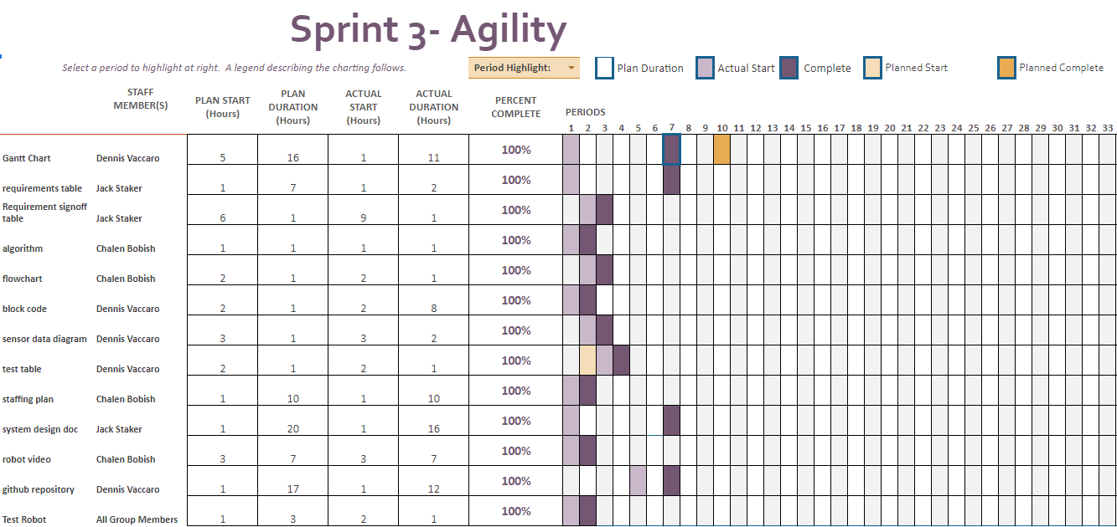

## ***Staffing Plan***

Insert a chart/table that depicts the roles and responsibilities of each team member that worked on this project

## 

| Name | Role | Responsibility | Reports To |
| --- | --- | --- | --- |
| Chalen | Data/Planning | algorithm, flowchart, and robot testing | Jack |
| Dennis | Programmer | block code, test robot, Gantt chart, Sensor data diagram maintain Github | Jack |
| Jack | Manager | System design document, robot testing | N/A |